Auto Shutdown Application

Abstract
This documentation has been prepared to give an overview of the Auto Shutdown desktop based application. This automated application let one’s computer automatically schedule tasks. It also enables user to accomplish its way to schedule any event by fixing specific time, daily etc. This scheduler application works with loading the system time for executing the selected task. In this era, power outages have happened, but Auto Shutdown application saves both electricity and money for people.

Introduction
This Auto Shutdown application can easily schedule any computer to shut down, log off, restart, sleep and close power at any time by user’s need (daily, at a specified time, or sometime later). After anyone starts the task, this will run in the background and a double-click will get the main interface back from the tray to the desktop. All of the application settings are available to the user from a single window, which makes the application very easy to use.
Project Description
All of the above-mentioned tasks can be carried out in four different ways. The default is to execute them at a specific time, like 12:00 p.m., daily. Anyone can also specify a date along with a time, which gives user more freedom. And the next way is basically a count-down timer. User can tell it how many hours and minutes he (user) wants it to count down before a task is executed. But the last can execute any task when the computer put on idle mode.
At the top of the screen, user will see when the next task will be carried out. Optionally, he can have Auto Shutdown remind, it is five minutes before the task is executed to save the ongoing work or task.
When user is done setting the application, he (user) can hit on "Start", which will send it to the background. He can find it in the taskbar if he needs to make any changes.
This application is designed to help anyone to save time with many of its tasks, so it’s definitely worth trying out. The only minor disadvantage that Auto Shutdown requires a lot of resource, but its functionality is worth the trouble.

Feature:

Schedule the PC to Shut Down, Restart, Hibernate, Sleep, Lock or Sign out

This Auto Shutdown application enables to set the PC shut down, restart, hibernate, sleep, lock or sign out on a regular basis or only once, at a specific time. It makes your power management much easier and more convenient.

Schedule the Tasks at Any Time You Want
With Auto Shutdown desktop application, user can schedule the task to be executed daily, at an exact time, on a certain date and time or after an amount of time it sets manually passes from the moment when the task is set active. He can enable reminders so he will be notified 5 minutes before it executes the task. If you have unfinished business by then, you can delay the task by 10 minutes or up to 4 hours.

Concise and Effective User Interface
Interface of Auto Shutdown application can’t be any simpler. There are no menus, no complicated options or dialog boxes. It is clearly divided into two panels. User can easily select which task he wants to perform on the left and specify time when he wants that task to be executed on the right, then start the task. He can get the hang of it in seconds.

Silent Running Mode
When a task starts, Auto Shutdown application will minimize in the system tray and run silently in the background. if user right-click on its icon, the menu that appears will allow you to immediately restart or shut down the computer, with a single mouse click.

How to Use Auto Shutdown to Shut Down Your PC Automatically

Auto Shutdown is a utility application to shut down your PC automatically. With its help, anyone can easily schedule a computer to shut down, log off, restart, sleep, and close power at any time of its need.

Step 1: After launching Auto Shutdown application, user will find the task and time are listed in two parts.

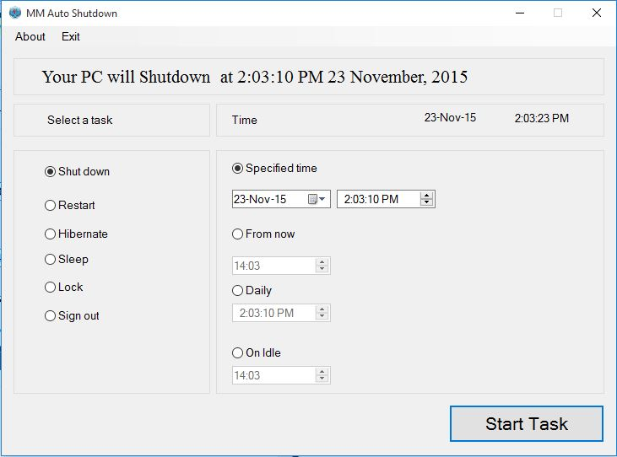

Step 2: Please select a task type to take and set a schedule.

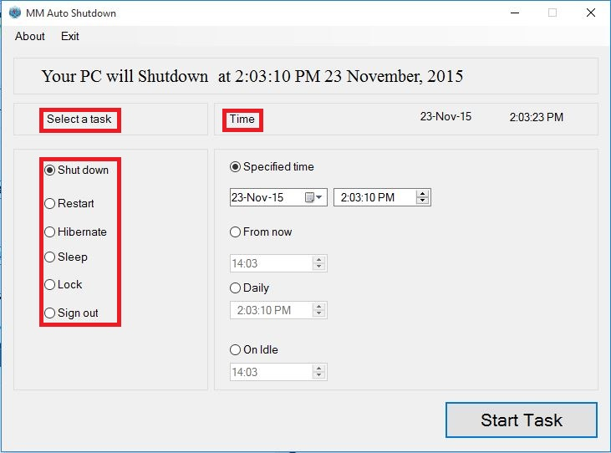

Step 3: After the setting is finished, please click “Start Task”.

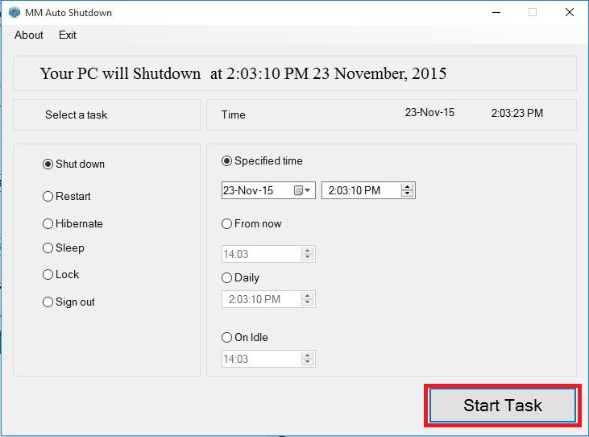

System tools
- Language: C#
- Editor: Microsoft visual studio 2015

Conclusion
Our desktop based utility application has been designed to help computer being automated by scheduling different tasks as user needs. We have planned to execute some computational application using this tool.

